Early Autonomous strategy

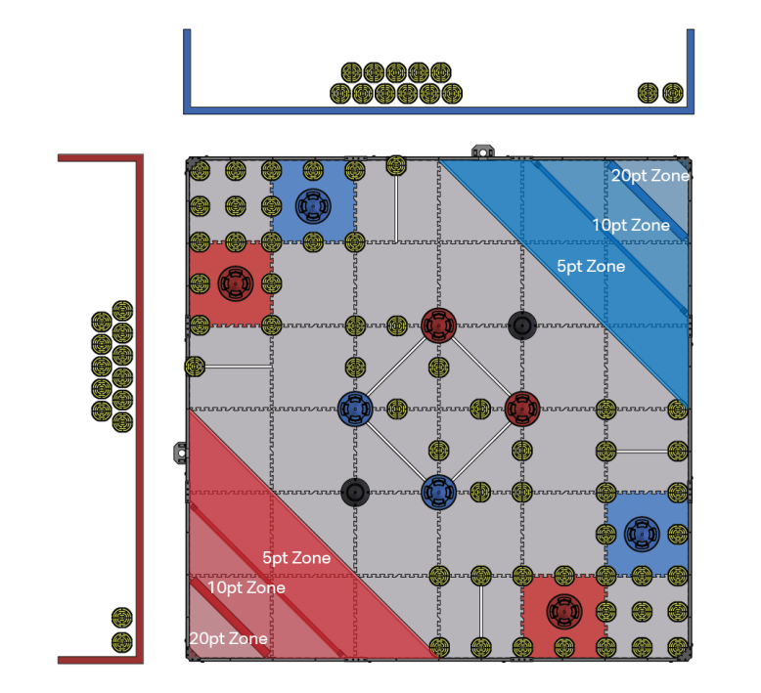

# Key

Movement

Scoring a cone

Scoring a cone

# Red Path

Point Breakdown

# Red Path

**Points**: 12

**Difficulty**: Difficult

**Description:**

This strategy is an extension to the red path where we pick up the mobile goal after and then drive back and score it in the 10 point zone.

**Points**: 4

**Difficulty**: Medium

**Description:**

This strategy is drive forward towards the mobile goal and stack the preload on it then move slightly forward for the parking bonus. This also makes driver control easier as we already a the mobile goal.

**Points**: 2

**Difficulty**: Easy

**Description:**

This simple strategy is to simply move forward and stack the preload on the static goal

# Green Path

|  |  |  |  |  |  |  |
| --- | --- | --- | --- | --- | --- | --- |
| **Category** | **Name** | **Individual points** | **Amount** | **Overall points** | **Percentage** | **Difficulty** |
| Autonomous | Win | 10 | 1 | 10 | 06.29% |  |
| Cones | On Field | 2 | 26 | 52 | 32.70% |  |
| Preload | 2 | 2 | 4 | 02.52% |  |
| Driver Load | 2 | 12 | 24 | 15.09% |  |
| Mobile Goal | 20pt Zone | 20 | 1 | 20 | 12.58% |  |
| 10pt Zone | 10 | 3 | 30 | 18.87% |  |
| Highest Stack | 20pt Zone | 5 | 1 | 5 | 03.14% |  |
| 10pt Zone | 5 | 1 | 5 | 03.14% |  |
| Static Goal | 5 | 1 | 5 | 03.14% |  |
| Park Bonus | Team square | 2 | 2 | 4 | 02.52% |  |
| **Total** | **Everything** |  |  | **159** | **100%** |  |
| Autonomous | Total | 10 | 1 | 10 | 06.29% |  |
| Cones | Total | 2 | 40 | 80 | 50.31% |  |
| Mobile Goal | Total |  |  | 50 | 31.45% |  |
| Highest Stack | Total | 5 | 3 | 15 | 09.43% |  |
| Park Bonus | Total | 2 | 2 | 4 | 02.52% |  |

Looking at the statistics above we can see scoring mobiles goals is the easiest way to score a high amount of points. Being relatively easy to score and making up 31.45% of the average max points, scoring cones is an easy way to gain lots of points early in the round. Because of this we think that we will see a lot of robots focusing on just scoring the mobile goals in the first quarter of the season before the main robot design meta emerges. The parking bonus is also easy to get, however since it is only equal to 2.52% of points it is negligible. The autonomous bonus and highest stack bonus are dependent on the skill level of the opposite team and have no static difficulty. Lastly, we come to cones. these are the highest way to score points however in our opinion they are also the hardest. We think that the scoring of cones in the beginning of the season will not as important but as time passes and robots improve it will become more of an significant factor in scoring.

# Analysis